**Contents:**

**1) Introduction: 1**

**2) The Christian Pentecost: The Coming of the Holy Spirit: 1**

**a) Biblical Account (Acts 2:1–4): 1**

**b) Peter’s Sermon and the Birth of the Church: 2**

**3) Historical Development of the Feast: 2**

**a) Early Church Observance 2**

**b) Medieval and Modern Traditions 2**

**4) Conclusion: 2**

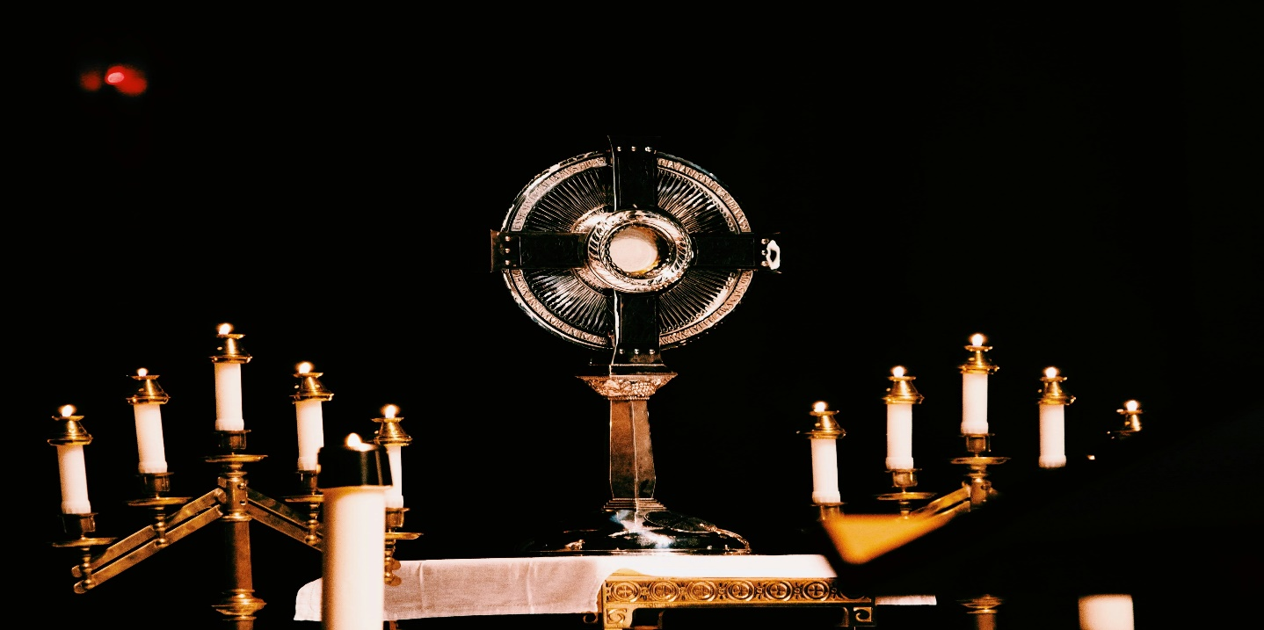

**History Of Pentecost.**

# **Introduction:**

Pentecost is one of the principal feast days in Christianity, celebrated on the seventh Sunday after Easter. It commemorates the descent of the Holy Spirit upon the apostles and early followers of Jesus Christ, a foundational moment for the Christian Church. The word Pentecost means "fiftieth" in Greek, signifying the number of days after Easter it is observed.

# **The Christian Pentecost: The Coming of the Holy Spirit:**

## **Biblical Account (Acts 2:1–4):**

According to the Book of Acts in the New Testament, on the day of Pentecost, the apostles were gathered in one place when suddenly a sound like a rushing wind filled the room. Tongues of fire appeared above their heads, and they were filled with the Holy Spirit. They began speaking in different languages, allowing the multicultural crowd in Jerusalem to understand them in their native tongues.

## **Peter’s Sermon and the Birth of the Church:**

Moved by the Spirit, the Apostle Peter addressed the crowd, interpreting the event as the fulfillment of the prophecy from the Book of Joel. His sermon resulted in the conversion and baptism of about 3,000 people. This moment is often regarded as the birth of the Christian Church, as it marked the beginning of its public ministry and evangelistic mission.

# **Historical Development of the Feast:**

## **Early Church Observance**

The earliest Christians celebrated Pentecost alongside the Jewish festival but gave it new meaning. By the 2nd century, it was observed as a distinct Christian feast. The Didache and early church fathers like Irenaeus and Tertullian mention Pentecost in their writings.

## **Medieval and Modern Traditions**

In the Middle Ages, Pentecost became one of the most important liturgical celebrations. Churches held elaborate services, and some would even release doves or drop rose petals from the ceiling to symbolize the Holy Spirit’s descent.

Today, Pentecost is still widely celebrated in Catholic, Orthodox, and Protestant churches. The color red, symbolizing the fire of the Holy Spirit, is typically used in church decorations and vestments.

# **Conclusion:**

Pentecost is a rich and multi-layered celebration that bridges Jewish and Christian traditions. It marks a pivotal turning point in Christian history—the empowerment of the apostles, the start of worldwide evangelism, and the formation of the Church as a living, Spirit-filled community. Its enduring relevance speaks to the transformative power of the Holy Spirit in individuals and communities alike.